37.70: a) As in the hint, both the sender and the receiver measure the same distance. However, in our frame, the ship has moved between emission of successive wavefronts, and we can use the time 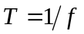as the proper time, with the result that 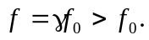
b) Toward: 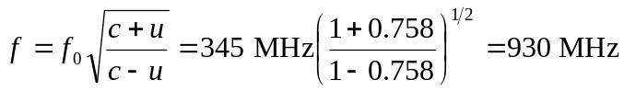
Away:
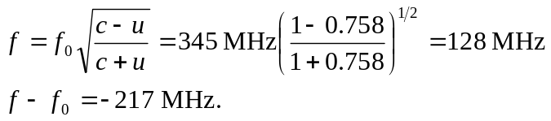
c) The shift is still bigger than 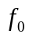, but not as large as the approaching frequency.

